Volcanism and earthquake:

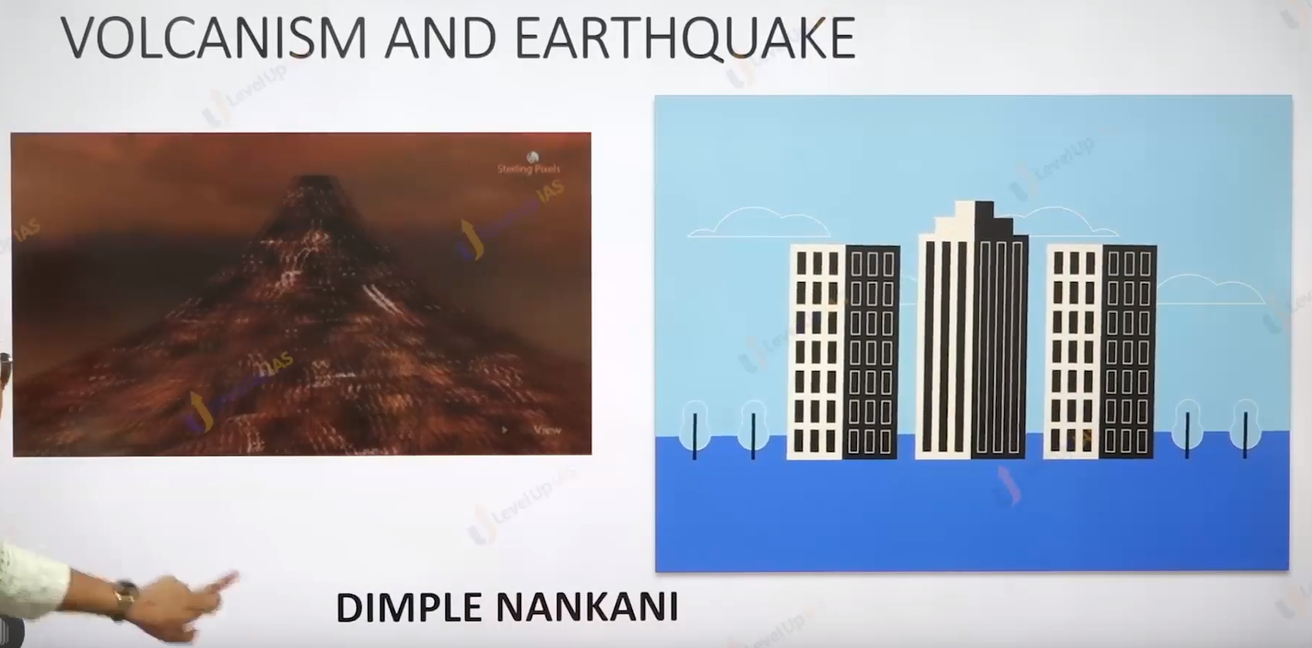

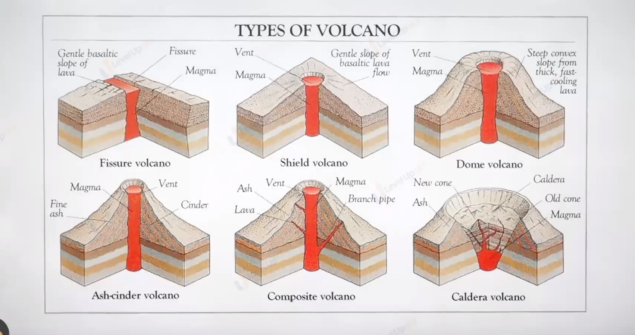

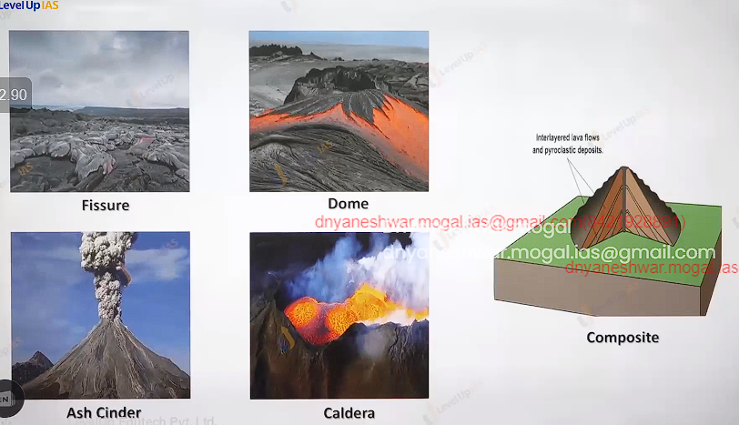

Intrusive volcanic landform:

1. Cooling of magma can acquire various shape horizontal to vertical etc.

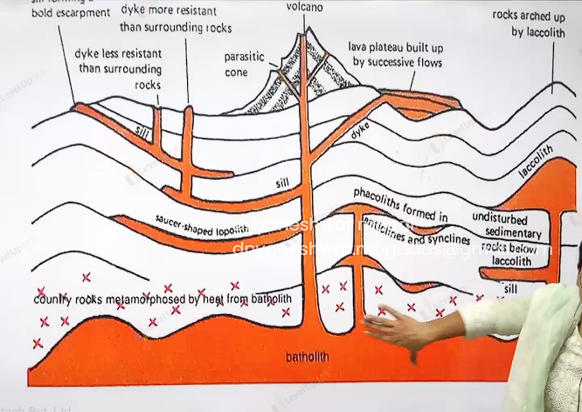

Bathetic the cooling of magma chamber these are granitic body they rare appeared on the surface denudation process removed overlaying material. Shield refers to expose bathetic.

Laccolith these are large dome shape bodies connected by the pipe like conduit from below it resembles the shape of mushroomed. Lopolith is saucer shape cooling of magma.

Sill: horizontal shaped bodies thinner one’s are sheet and thicker sill.

Dyke: its vertical shape pipelike structure.

**Process shaping the landform:**

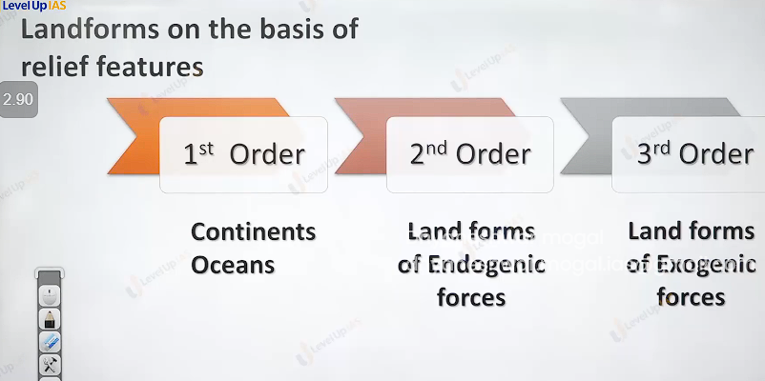

**Landform on the basis of relief feature:**

1st order relief feature

2nd order relief feature: land form because of these endogenic forces. Like volcanic land form, fold mountains block and faults. Rift valleys.

3rd order relief feature: these are landform which are formed because of exogenic forces

Ex. Landform formed by glaciers river and wind.

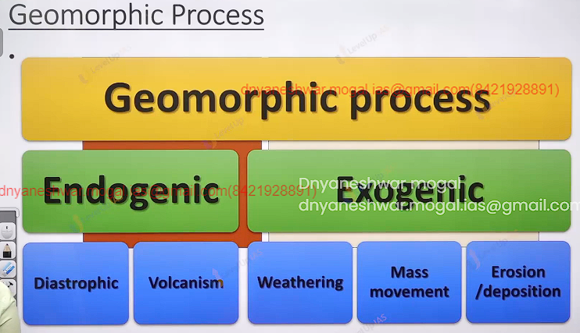

Geomorphic process: geo means earth and morphic shape therefore geomorphic process refers the process that have been shapes earth. It can be two type endogenic and exogenic.

There are two types of endogenic Diastrophic / catastrophic.

Diastrophic ex Plate tectonic theory.

Catastrophic: ex volcanism and earthquake

Endogenic process: these refers internal forces as they are powered by earth’s interior energy is generated in earth interior by radioactivity and residual heat.

These forces are called as land building forces as they help in elevation and building of earth crust.

They are two types slow building and fast building. Slow building is called as diastrophic forces it includes orogenic forces.

Mountain building forces and include epeirogeny forces continent building forces.

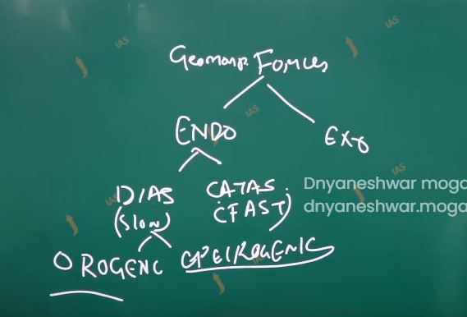

Catastrophic refers to fast process that shape earth ex volcanism and earthquake.

Exogenic process:

1. The external forces which are induced by sunlight are called as exogenic forces. Evens out (reduces) the variation on the surface of earth.
2. Therefore, called land wearing forces. Any exogenic element of nature like water ice wind wave capable of transporting earths material is called geomorphic agent. This geomorphic agent becomes active due to the difference in the slope.
3. They try to erode material from the top slope, transport it over the slope and deposited them at lower level therefore they are derived their energy form the gradient. (all exogenic processes are covered under general term denudation.)

**Denudation process/forces:**

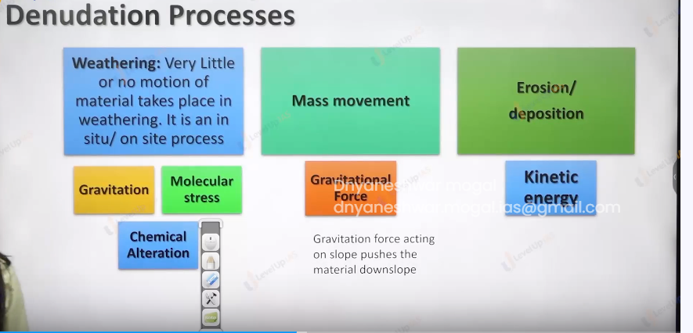

1. Type   
   1) weathering: weather refers to disintegration of the rock into fragments it involves little or no movement material i.e. incetuo movement
   1. Chemical weathering
   2. Physical weathering
   3. Biological weathering.

There are 3 type denudations:

1. Physical weathering: involves expansion forces due to temperature changes it can be also because of expansion water to ice and vice versa. Over burden pressure or load.
2. chemical weathering: the breaking of rock due chemical it include the solution hydration oxidation and reduction.
3. Biological weathering: it refers to breaking of rock due to biological organism earthworm and tree.
4. Special landform: by physical weather is onion peeling exfoliation
5. Mass movement it refers to transfer of rock debris from the slope under the direct influence of gravity it ranges from slow movement to very fast movement it can affect shallow to deep columns.
6. Weathering is not prerequisite for mass movement, no agent like running water, glacier, wind and wave participate in process of mass movement.
7. Example of mass movement creep, flow, fall, slump (contains rotation layer by layer).
8. Creep: its slow movement of the land hardly perceptible it occurred in moderately steep slope, forested slope.

Ex Electric post may occur to be bent because of the creep effect.

1. Flow movement: earth flow mud flow, avalanche: it is rapid movement generally associated with saturated water later in the absence of vegetation avalanche refers movement of snow.
2. Fall movement: exception it will not contain water saturation.

Ex Water fall, snow fall.

1. Solifluction: it refers to downslope movement water saturated soil it can cause the subsidence of building around its solifluction can also have slow movement of soil it is generally seen in place where ground water is occupied in between permanently frozen soil. Movement involved in land slide is of dry material. Ex rock slide debruise side, slump.
2. Slump: it form of land slide in which many units of debris slide backwards in relation to slope over which movement occurred.
3. . 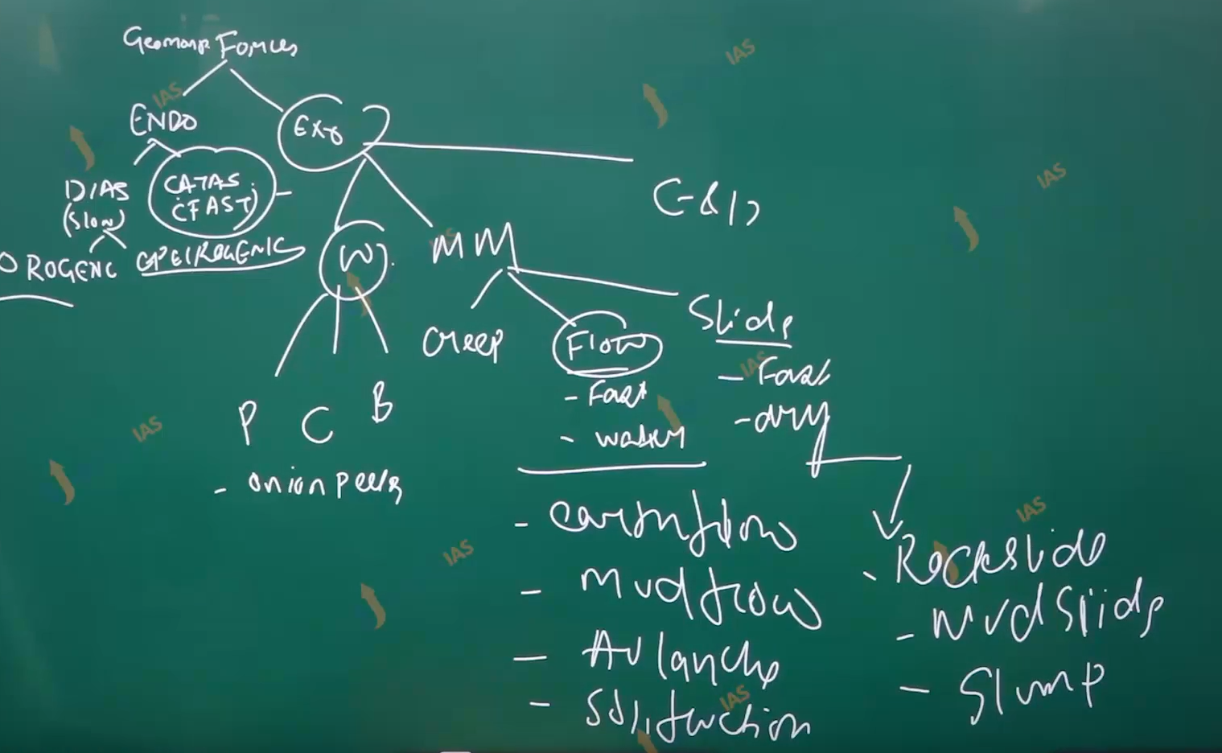
4. . 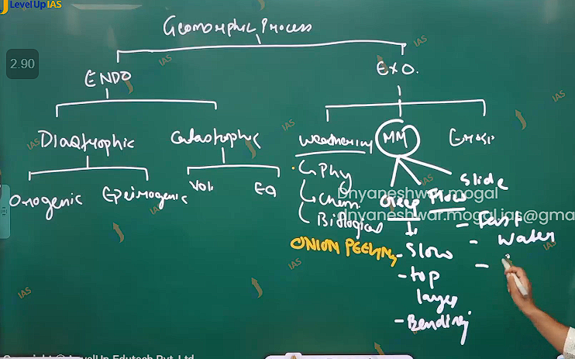
5. .
6. Erosion /deposition: erosion is process rock debris are collected and transported by geomorphic agent like wind wave river glacier. Weathering enhances erosion although it is not prerequisite for erosion. Deposition fallow erosion on moderate slope the geomorphic agent loss their velocity and energy. And therefore material they carry begin to settle.

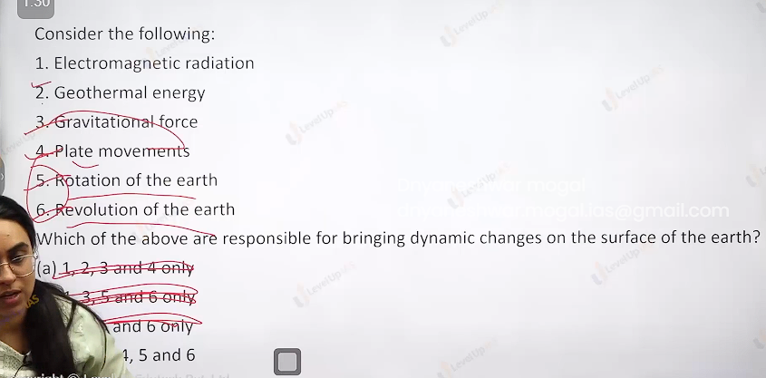

Paleomagnetism: paleo means old certain rocks preserve the magnetic field and can align to earth magnetic field. Paleomagnetic give proofs earth evolution and change magnetic orientation of the earth. The majority of the ocean floor is made by basalt (low silica and iron rich). When basalt ocean floor is heated due to volcanism the magnetic minerals in the basalt realign with the magnetic field. as rocks start solidify the band rocks are seen along the mid oceanic ridge. When paleomagnetic rocks were on either side of mid oceanic ridge it was discovered that rocks had alternate magnetic field. As a result it pointed that the sea floor had spread the magnetic field which rivers Is preserved in the rocks.

<https://www.thehindu.com/sci-tech/energy-and-environment/warming-pacific-points-to-rise-in-cyclones-over-india-study/article67245627.ece>

For Foundation 2.0 Students- Hints wrt the question given in class. What is ‘Protected discrimination’? Examine how far it is constitutional under Article 15 and 16.

Hint: Protected discrimination refers to provisions or actions that allow for differentiation or preferential treatment to class or classes who were subject to historical injustice and social exclusion. These provisions aims to protect marginalized or underrepresented groups by providing them with opportunities and safeguards.

Once India got free from colonial rule the preamble as well as the specific provisions of the constitution of India tries to establish equality of opportunity of status and opportunity where no one shall be discriminated. However, during its inception it was non reasonable to incorporate absolutely no discrimination because that would itself have perpetuated the social divided created in the past. So constitution makers found it fair to give certain protection to class of citizen by relaxing the equality and hence it can be called as protective discrimination including the power of state to go for affirmative action.

Some of the manifestations of protective discrimination are found in mainly under article 15, article 16 along with some provisions under article 29, article 30, article 330, 332, article 335 etc.

• Article 15: The article itself forbids discrimination on the basis of race, religion, caste, sex and place of birth, but in later clauses empowers state to make special provisions for protection of women and child, advancement of SEBC or SC or ST including reservation in admission to educational institution. Recently, this protection has been extended to economically weaker section of the society as well.

• Article 16 generally provides for equality of opportunity in matters of public employment but Under Art. 16(4), the state may make reservation of appointments or posts in favour of any ‘backward class’ of citizens which, in the opinion of the state, is not adequately represented in the public services under the state.

It may be noted that, they “an enabling provision” conferring a discretionary power on the state for making any provision or reservation of appointments or posts in favour of any backward class of citizens which, in the opinion of the state, is not adequately represented in the service of the state. Art. 16(4) neither imposes any constitutional duty nor confers any Fundamental Right on any one for claiming reservation.

However, Reservation does not rule out merits. Judgment of merit may be at several tiers. It may undergo several filtrations. The disadvantaged group or the socially backward people may not be able to compete with the open category people but that would not mean that they would not be able to pass the basic minimum criteria laid down therefor.

The equality of opportunity guaranteed by Art. 16(1) is to each individual citizen of the country while Art. 16(4) contemplates special provision being made in favour of the socially disadvantaged classes. Both must be balanced against each other. Neither should be allowed to eclipse the other. Hence, courts have tried to fix a limit of 50% on the reservations in the Indira Sawhney case.

Due to G20 Summit in Delhi, LevelUp IAS had to close classrooms between Sep 8, 2023 to Sep 10, 2023.

Therefore, for this week’s classes we have uploaded the videos on Youtube. These are very comprehensive videos for the two topics as they were done for Mains 2023 students and cover every aspect of the syllabus.

The notes have already been shared to you.

Here, we are also sharing the video links:

1. Issues Related to Poverty and Hunger: https://youtu.be/huvlPdA_zoI?si=sicJmuqfldH4SSIv

2. Cyber Security in India: https://youtu.be/ftEhKLGrfxg?si=puNCbT9-9a_ujNWf

3. Emerging Trends in Cyber Security: https://youtu.be/a02RDbXwNp8?si=-C_GdROJh5ZvuaNp

Please leave your doubts in the comment section and I will try to answer them today only.

Thanks,

<https://www.youtube.com/watch?v=MC6pkgOwxoo>

<https://youtube.com/live/dq6fQF77LHU?feature=share>

<https://youtube.com/live/5E-2CjnO7zw?feature=share>

<https://forms.gle/gSimmAZWJAty2V5C9>

<https://youtube.com/live/iAcyZQxI5lQ?feature=share>

<https://youtube.com/live/ya7OSkZJKSA?feature=share>

<https://www.thehindu.com/business/Industry/regulating-ott-platforms-reignites-indias-net-neutrality-debate/article67372223.ece>

<https://indianexpress.com/article/india/its-her-decision-vs-cant-stop-heartbeat-sc-divided-on-ending-26-week-pregnancy-8978969/>

<https://youtu.be/-24T4LBghBQ>

All those who could have missed in dictation please find below the Questions which were given in polity class today and will be taken up for discussion tomorrow:1. Discuss the desirability of greater representation to women in the higher judiciary to ensure diversity, equity and inclusiveness.

2. Judicial Legislation is antithetical to the doctrine of separation of powers as envisaged in the Indian Constitution. In this context justify the filing of large number of public interest petitions praying for issuing guidelines to executive authorities.

3. Judiciary has acquainted the role of both the legislature and executive in recent years. Examine with suitable examples.

4. Whether judicial activism has undermined or strengthened the parliamentary democracy in India, Discuss.

5. What is public interest litigation? What are the major facets of this form of litigation? Also discuss the limitations of this type of litigation.

6. The horizon of legal aid has been widened at best. Still, the impact is totally missing. Suggest some concrete measures to make it more effective.

<https://www.youtube.com/live/DVMGQLO4V50?si=pS5Q4FgKGojEHnSy>

<https://www-livelaw-in.cdn.ampproject.org/c/s/www.livelaw.in/amp/top-stories/supreme-court-high-courts-speedy-disposal-cases-directions-240729>

To ensure sincerity among online students and to bring them on par with the options available with offline/classroom students, we will be changing subjective test submission deadline from next week.

Now you won’t get Monday and Tuesday for submission.

The test should be submitted by End of DAY (Midnight) Sunday only.

This will ensure more discipline among students. This will also allow us to publish Model Answers early. Else students have to wait for two days to have a look at model answers. Further, it would fast track evaluation process and your evaluated copies will be given back to you by Wednesday EOD.

So, from next test, kindly plan to submit your copies by Sunday midnight only.

We prepare the syllabus and provide it to you guys in advance (i.e By Monday) so that you don’t face any eleventh hour hurdle. But as you could understand that the topics in syllabus are put in anticipation only not on real time basis. Final scenario overage of topics wrt to becomes clear only after classes for the week has been completed.

It might happen sometimes that certain topics mentioned for the week could not be completed due to prolonged discussion or classroom doubt or even sometimes more than anticipated are covered in class.

But in any case nothing which has not been covered in your class shall be asked in your test. We at backend are in regular touch with regards to completion of topics and tests are prepared accordingly. I have already informed the coordination team to keep those topics out of test which has not been covered yet in class, out of the test and questions on the same shall not be included in tests. So be rest assured that due caution are being taken at our end.

We also don’t change the syllabus frequently, as it could confuse other students. But we are aware about the things and keep the same in mind while making questions.

Dear students, tests conducted weekly are not simply to rank your performance, rather it serves a greater purpose, to provide you avenues for checking quality of your prep and enabling you to revise better in lines with demand of examination. Hence, we should try to be more and more disciplined in tests and appear in those test during prescribed times.

Remember, if you want to achieve big things in life, you need to take little things very seriously bigger things will be taken care automatically. This is biggest life lesson I have learned from a very learned man, and I also urge all of you to simply maintain punctuality and consistency in these weekly/monthly tests. Tests are those little thing for bigger goal of your life.

Do not simply worry about your ranks or marks in test, you are not competing with your batchmates merely, firstly you are competing with yourselves. With every such test only aim should be to improve from your previous performance, and only this could be done with sincere revision which I hope everyone is doing with great seriousness. Hoping see you all coming out with flying colours in exam.

<https://www.youtube.com/live/L3MCNQVRfxg?si=69vtR1EHzK7tMNqN>

<https://youtu.be/sdzH7mt7rFU>

<https://youtube.com/live/wSsEHRdSDVE?feature=share>

https://www.youtube.com/live/_vd99ZE-KfA?si=-1Avbqi-sSKMy0c6